**Laplace Transformation**

**Definition:** Let the function $f(t)$ be defined for all positive values of $t$, then multiply $f(t)$ by $e^{-st}$ and integrate it with respect to $t$ from zero to infinity. If the resulting integral exists (i.e., has some finite value), it is a function of $s$, $s$ may be real or complex, say $F(s)$.

$$F\left(s\right)=\int_{0}^{∞}{e^{-st}f\left(t\right)dt}.$$

This function $F(s)$ of variable $s$ is called Laplace Transformation of the original function $f(t)$ and will be denoted by $L\left\{f\left(t\right)\right\}$, where $L$ denotes the Laplace transform operator. Thus

$$L\left\{f\left(t\right)\right\}=F\left(s\right)=\int_{0}^{∞}{e^{-st}f\left(t\right)dt}.$$

The original function $f(t)$ is called the inverse transform or inverse of $F\left(s\right)$ and will be denoted by $L^{-1}\left\{F(s)\right\}$.

$${∴f\left(t\right)=L}^{-1}\left\{F(s)\right\}.$$

**Important formulae:**

|  |  |
| --- | --- |
| $$1.L\left\{c\right\}= \frac{c}{s}, c is any constant, (s>0)$$ | **Some important formulae** |
| $2.L\left\{t^{n}\right\}= \frac{n!}{s^{n+1}}$, when $n=0,1,2,3,...$ | $$\sin{at}=\frac{e^{iat}-e^{-iat}}{2i}$$ |
| $$3.L\left\{e^{at}\right\}= \frac{1}{s-a}, (s>a)$$ | $$\cos{at}=\frac{e^{iat}+e^{-iat}}{2}$$ |
| $4.L\left\{\cosh{at}\right\}= \frac{s}{s^{2}-a^{2}},$ | $$\sinh{at}=\frac{e^{at}-e^{-at}}{2}$$ |
| $5.L\left\{\sinh{at}\right\}= \frac{a}{s^{2}-a^{2}},$ | $$\cosh{at}=\frac{e^{at}+e^{-at}}{2}$$ |
| $6.L\left\{\cos{at}\right\}= \frac{s}{s^{2}+a^{2}},$ | $$\int{e^{at}\sin{bt} dt=\frac{e^{at}(\operatorname{asin}{bt}-b\cos{bt})}{a^{2}+b^{2}}}$$ |
| $7.L\left\{\sin{at}\right\}= \frac{a}{s^{2}+a^{2}},$ | $$\int{e^{at}\cos{bt} dt=\frac{e^{at}(\operatorname{acos}{bt}+b\sin{bt})}{a^{2}+b^{2}}}$$ |

**Properties of Laplace transformation:**

1. **(linearity)**, where $a$& $b$ are constants.

2. If then $L\left\{e^{at}f\left(t\right)\right\}=F(s-a)$**(first shifting or translation)**

3. If then $L\left\{t^{n}f\left(t\right)\right\}={(-1)}^{n}\frac{d^{n}}{ds^{n}}[F\left(s\right)]$**(multiplication by $t^{n}$)**

**Proof of some selective formulae:**

$$1. L\left\{e^{at}\right\}= \frac{1}{s-a}, (s>a)$$

**Proof**: From the definition of Laplace transformation we know that,

.

2. and 3. .

**Proof: $L\left\{e^{iat}\right\}=\frac{1}{s-ia}=\frac{s+ia}{s^{2}+a^{2}}=\frac{s}{s^{2}+a^{2}}+i\frac{a}{s^{2}+a^{2}}$** - - - - - (1)

But, $e^{iat}=\cos{at+i\sin{at}}$

So,

- - - -- - (2)

Comparing (1) and (2), we have on equating real and imaginary parts,

$L\left\{\cos{at}\right\}=\frac{s}{s^{2}+a^{2}}\text{if}$ and $L\left\{\sin{at}\right\}=\frac{a}{s^{2}+a^{2}}\text{if}$.

**Some workout examples on Laplace transformation:**

|  |  |
| --- | --- |
| **Example: 1 $$L\left\{(t^{2}+1)^{2}\right\}$$ $$=L\left\{t^{4}+2t^{2}+1\right\}$$ $$=L\left\{t^{4}\right\}+2L\left\{t^{2}\right\}+L\left\{1\right\}$$ $$=\frac{4!}{s^{4+1}}+2\frac{2!}{s^{2+1}}+\frac{1}{s}$$ $$=\frac{24}{s^{5}}+\frac{4}{s^{3}}+\frac{1}{s}$$** | **Example: 2 $$L\left\{e^{-3t}+5\cosh{t}\right\}$$ $$={L\{e}^{-3t}\}+5L\{cosh{ t\}}$$ $$=\frac{1}{s-(-3)}+5\frac{s}{s^{2}-1^{2}}$$ $$=\frac{1}{s+3}+\frac{5s}{s^{2}-1}$$** |
| **Example: 3 $$L\left\{(sin{t-\cos{t}})^{2}+cos^{2}{3t}\right\}$$ $$=L\left\{sin^{2}{t-2\sin{t}\cos{t+\cos^{2}t}}+\frac{1}{2}(1+\cos{6t})\right\}$$ $$=L\left\{1-\sin{2t}+\frac{1}{2}+\frac{1}{2}\cos{6t})\right\}$$ $$=L\left\{\frac{3}{2}\right\}-L\left\{\sin{2t}\right\}+\frac{1}{2}L\left\{\cos{6t}\right\}$$ $$=\frac{3}{2}\frac{1}{s}-\frac{2}{s^{2}+2^{2}}+\frac{1}{2}\frac{s}{s^{2}+6^{2}}$$ $=\frac{3}{2s}-\frac{2}{s^{2}+4}+\frac{1}{2}\left(\frac{s}{s^{2}+36}\right)$**  . | **Example: 4 $$L\left\{3-e^{-t}\cos{2t}+t \sinh{3t}\right\}$$ $$=L\left\{3\right\}-L\left\{e^{-t}\cos{2t}\right\}+L\left\{t\sinh{3t}\right\}$$ $$=3\frac{1}{s}-\frac{s+1}{(s+1)^{2}+2^{2}}+(-1)^{1}\frac{d}{ds}\left(\frac{3}{s^{2}-3^{2}}\right)$$ $$=\frac{3}{s}-\frac{s+1}{s^{2}+2s+5}+\frac{3.2s}{(s^{2}-9)^{2}}$$ $$=\frac{3}{s}-\frac{s+1}{s^{2}+2s+5}+\frac{6s}{(s^{2}-9)^{2}}$$** |
| **Example: 5 $$L\left\{t\cos{t-e^{-3t}\sin{2t+}}t^{7}e^{5t}\right\}$$ $$={\left(-1\right)}^{1}\frac{d}{ds}\frac{s}{s^{2}+1}-\frac{2}{{\left(s+3\right)}^{2}+2^{2}}+\frac{7!}{{\left(s-5\right)}^{8}}$$ $$=-\frac{1-s^{2}}{{(s}^{2}+1)^{2}}-\frac{2}{{\left(s+3\right)}^{2}+4}+\frac{5040}{{\left(s-5\right)}^{8}}$$** | **Example: 6 $$L\left\{e^{2t}t+e^{t}\cosh{3t}\right\}$$ $$=\frac{1}{{\left(s-2\right)}^{2}}+\frac{s-1}{{\left(s-1\right)}^{2}-3^{2}}$$ $=\frac{1}{{\left(s-2\right)}^{2}}+\frac{s-1}{s^{2}-2s-8}$**  . |
| **Example: 7 $$L\left\{t\sin{at}\right\}$$ $$=L\left\{t\frac{e^{iat}-e^{-iat}}{2i}\right\}$$ $$=\frac{1}{2i}L\left\{te^{iat}-te^{-iat}\right\}$$ $=\frac{1}{2i}\left[\frac{1!}{(s-ia)^{2}}-\frac{1!}{(s+ia)^{2}}\right]$**  (first Shifting Property) $$=\frac{2as}{(s^{2}+a^{2})^{2}}$$ **Or $$L\{t\sin{at}\}$$ $$=(-1)^{1}\frac{d^{}}{ds^{}}\left(\frac{a}{s^{2}+a^{2}}\right)$$ $$=-\frac{\left(s^{2}+a^{2}\right).0-a.2s}{{(s}^{2}+a^{2})^{2}}$$ $$=-\frac{-2as}{{(s}^{2}+a^{2})^{2}}$$ $$=\frac{2as}{{(s}^{2}+a^{2})^{2}}$$**  **Piecewise function** | **Example: 8 $$L\{t\cos{at}\}$$ $$=L\left\{t\frac{e^{iat}+e^{-iat}}{2}\right\}$$ $$=\frac{1}{2}L\left\{e^{iat}t+e^{-iat}t\right\}$$ $=\frac{1}{2}\left[\frac{1!}{(s-ia)^{2}}+\frac{1!}{(s+ia)^{2}}\right]$**  (first shifting property) $$=\frac{a^{2}-s^{2}}{{(s}^{2}+a^{2})^{2}}$$ Or $$L\{t\cos{at}\}$$ $$=(-1)^{1}\frac{d^{}}{ds^{}}\left(\frac{s}{s^{2}+a^{2}}\right)$$ $$=\frac{\left(s^{2}+a^{2}\right).1-s.2s}{{(s}^{2}+a^{2})^{2}}$$ $$=\frac{a^{2}-s^{2}}{{(s}^{2}+a^{2})^{2}}$$ |
| **Example:**  Sketch $f\left(t\right)=\left\{\begin{aligned} 0, & 0<t<2 \\ 4, &t>2\end{aligned}\right.$ and  find $L\{f\left(t\right)\}$.  **Solution:**  . |  |

**Reference Books:**

1. Advanced Engineering Mathematics- Erwin Kreyszig.(10th Edition)

2. Differential Equations- Paul Blanchard, Robert L. Devaney, Glen R. Hall (4th Edition)

**Problem Set 1**

**Find the Laplace Transforms and also sketch (if free hand sketching is getting complex then use MATLAB) the following functions (1-20):**

**Using direct formula**

1. **Ans:**

2. **Ans:**

3. **Ans:**

4. **Ans:**

5. **Ans:**

6. **Ans:**

7. **Ans:**

8. **Ans:**

**First shifting or Translation property**

If then

9. **Ans:**

10. **Ans:**

11. **Ans:**

12. **Ans:**

13. **Ans:**

**Property of multiplication by $t^{n}$**

If then

14. **Ans:**

15. **Ans:**

**Piece-wise Function**

If $f\left(t\right)$ is a piece-wise function then $L\left\{f\left(t\right)\right\}=\int_{0}^{∞}{e^{-st } f\left(t\right) dt}$

|  |  |
| --- | --- |
| 16. $f\left(t\right)=\left\{\begin{aligned}1-t ;0<t<1 \\ 0 ; t>1\end{aligned}\right.$ **Ans: $F\left(s\right)=\frac{s +e^{-s} - 1}{s^{2}}.$** | 17. $f\left(t\right)=\left\{\begin{aligned}k ; 0<t<c \\ 0 ; t>c\end{aligned}\right.$ **Ans: $F\left(s\right)= - \frac{k \left(e^{-c s} - 1\right)}{s}.$** |
| 18. $f\left(t\right)=\left\{\begin{aligned}b-t ;0<t<b \\ 0 ; t>b\end{aligned}\right.$ **Ans: $F\left(s\right)=\frac{e^{-bs} + bs - 1 }{s^{2}}.$**  20. $f\left(t\right)=\left\{\begin{aligned}t ;0≤t≤4 \\ 1 ; t>4\end{aligned}\right.$ Also sketch $f\left(t\right).$ **Ans: $F\left(s\right)=- \frac{e^{-4s} + 3s e^{-4s} -1 }{s^{2}}.$** | 19. $f\left(t\right)=\left\{\begin{aligned}1 ;0<t<1 \\ -1 ;1<t<2 \\ 0; t>2\end{aligned}\right.$ **Ans: $F\left(s\right)=\frac{e^{-2s} {\left(e^{s}-1\right)}^{2}}{s}.$** |

**The Unit step function (Heaviside function):**

In engineering applications, we frequently encounter functions whose values change abruptly at specified values of time *t*. One common example is when a voltage is switched on or off in an electrical circuit at a specified value of time *t*.

The value of *t* = 0 is usually taken as a convenient time to switch on or off the given voltage.

The switching process can be described mathematically by the function called the **Unit Step Function** (otherwise known as the **Heaviside function** after Oliver Heaviside).

The Unit step function or Heaviside’s unit step function $,u\left(t\right),$ is defined as follows:

$f\left(t\right)=u\left(t\right)=\left\{\begin{aligned}0, t<0 \\ 1, t≥0 \end{aligned}\right.$,

That is, is a function of time *t*, and *u* has value **zero** when time is negative (before we flip the switch); and value **one** when time is positive or zero (from when we flip the switch).

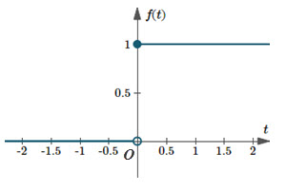

Graph of $f\left(t\right)=u\left(t\right),$ the unit step function.

**Shifted (Right) Unit step function:**

In many circuits, waveforms are applied at specified intervals other than t=0. Such a function may be described using the **shifted** (aka **delayed**) unit step function.

A function which has value0 up to the time $t=a$ and thereafter has value 1 is written:

$u_{a}\left(t\right)=u\left(t-a\right)=\left\{\begin{aligned}0, t<a \\ 1, t≥a\end{aligned}\right.$,

$u(t-a)$

1

O

a

t

**Rectangular pulse:**

A common situation in a circuit is for a voltage $V\left(t\right)$ to be applied at a particular time (say *t = a*) and removed later, at *t = b* (say). We write such a situation using unit step functions as:

$$V\left(t\right)=u\left(t-a\right)-u(t-b)$$

This voltage has strength 1, duration $\left(b-a\right).$

Alternatively, $V(t)$ may be constructed using top hat function $u\left(t-a\right)-u(t-b)$ as follows:

$V\left(t\right)=u\left(t-a\right)-u(t-b)=\left\{\begin{aligned}1, a≤ t<b \\ 0, otherwise\end{aligned}\right.$,

**Example01 :**

The graph of $V(t)=u(t-1.2)-u(t-3.8)$ is as follows. Here, the duration is 3.8−1.2=2.6 .

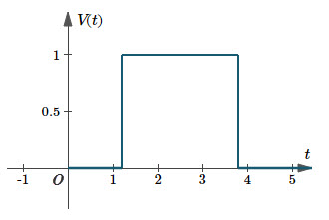

Graph of $V(t)=u(t-1.2)-u(t-3.8)$ is an example of a rectangular pulse.

**Example 02:**

Write the following functions in terms of **unit step** function(s). Sketch each waveform.

1. A 12-V source is switched on at *t* = 4 s,
2. $V\left(t\right)=\left\{\begin{aligned}1, 0< t<a \\ 0, t>a\end{aligned}\right.$ and,
3. $V\left(t\right)=\left\{\begin{aligned}0, t<3 \\ 2t+8, 3<t<5 \\ 0, t>5\end{aligned}\right.$.

**Solution:**

**(i)**Since the voltage is turned on at t = 4, we need to use $u(t-4).$ We multiply by 12 since that is the voltage.

We write the function as follows: $V(t)=12⋅u(t-4)$

Here's the graph:

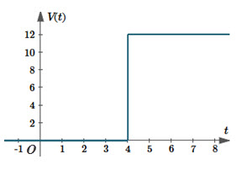

Graph of $V(t)=12⋅u(t-4)$

**(ii) $V\left(t\right)=\left\{\begin{aligned}1, 0< t<a \\ 0, t>a\end{aligned}\right.$**,

In words, the voltage has value 1until time $t=a$. Then it is turned off.

We have a "rectangular pulse" situation and need to use this formula:

$$V(t)=u(t-a)-u(t-b)$$

In our example, the pulse starts at $t=0$, so we use $u(t)$ and finishes at $t=a$ so we use

$u\left(t-a\right).$ So the required function is:

$$V(t)=1⋅[u\left(t\right)-u\left(t-a\right)]$$

Here is the graph

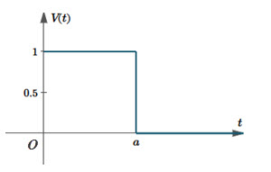

Graph of $V(t)=1⋅[u\left(t\right)-u\left(t-a\right)]$, a shifted unit step function

**(iii) $V\left(t\right)=\left\{\begin{aligned}0, t<3 \\ 2t+8, 3<t<5 . \\ 0, t>5\end{aligned}\right.$**

In this example, our function is $V(t)=2t+8$ which has slope 2 and V-intercept 8.

The signal is only turned on between $t=3$ and $t=5$. The rest of the time it is off.

So our voltage function will be:

$$V\left(t\right)=\left(2t+8\right)⋅[u\left(t-3\right)-u\left(t-5\right)]$$

The graph is as follows:

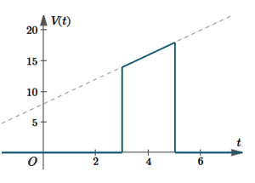

Graph of $V\left(t\right)=\left(2t+8\right)⋅[u\left(t-3\right)-u\left(t-5\right)]$. The dashed line is $V\left(t\right)=\left(2t+8\right).$

Now, the Laplace transform of **unit step function** is,

$$L\{1.u\left(t-a\right)\}=\frac{e^{-as}}{s}$$

$$L\{f(t).u\left(t-a\right)\}=e^{-as}L\{f(t+a)\}$$

**Example: 01**

Find the Laplace transformation of $t^{2}u\left(t-3\right).$

**Solution: $L\left\{t^{2}u\left(t-3\right)\right\}=e^{-3s}{L\{\left(t+3\right)}^{2}\}$**

$$=e^{-3s}{L\{t}^{2}+6t+9\}$$

$$=e^{-3s}\left[\frac{2}{s^{3}}+6\frac{1}{s^{2}}+9\frac{1}{s}\right].$$

**Example: 02**

Find the Laplace transformation of $e^{-2t}u_{π}\left(t\right).$

**Solution: $u_{π}\left(t\right)=\left\{\begin{aligned}0, t<π \\ 1, t>π\end{aligned}\right.$**  .

$$=u\left(t-π\right)$$

$$L\{e^{-2t}u_{π}(t)\}=e^{-πs}L\{f(t+π)\} =e^{-πs}L\{e^{-2(t+π)}\}$$

$$=e^{-πs}L\left\{e^{-2t}e^{-2π}\right\}=e^{-πs}e^{-2π}L\left\{e^{-2t}\right\}=e^{-π\left(s+2\right)}\frac{1}{s+2}.$$

**Example: 03**

Find the Laplace transformation of $t{ u}_{2}\left(t\right).$

**Solution: $L\left\{t{ u}_{2}\left(t\right)\right\}=L\{t u(t-2)\}$**

$$=e^{-2s}L\{t+2\}$$

$$=e^{-2s}\left(\frac{1}{s^{2}}+2\frac{1}{s}\right)$$

$$=e^{-2s}\left(\frac{2}{s}+\frac{1}{s^{2}}\right).$$

**Example: 04**Given $f\left(t\right)=\left\{\begin{aligned}8, 0<t<2 \\ 6, t>2\end{aligned}\right.$,

1. sketch ,
2. convert to unit step function and,
3. find the Laplace transformation of.

**Solution:**

|  |  |
| --- | --- |
|  | $f\left(t\right)=8\left[u\left(t-0\right)-u\left(t-2\right)\right]+6[u\left(t-2\right)]$ $$=8\left[u\left(t-0\right)]-2[u\left(t-2\right)\right]$$ $L\left\{f\left(t\right)\right\}=L\left\{8\right\}-2L\{u\left(t-2\right)\}$ $$=\frac{8}{s}-2.\frac{e^{-2s}}{s}.$$ |

**Example:05**Given $f\left(t\right)=\left\{\begin{aligned}E, a< t<b \\ 0, t>b\end{aligned}\right.,$ where E, *a* and *b* are positive constants.

1. sketch ,
2. convert to unit step function and,
3. find the Laplace transformation of.

**Solution:**

|  |  |
| --- | --- |
|  | $f(t)=E\left\{\begin{aligned}1 a< t<b \\ 0 t>b\end{aligned}\right.$ $$=E[u\left(t-a\right)-u(t-b)]$$ $L\left\{f\left(t\right)\right\}=EL\left\{u\left(t-a\right)-u(t-b)\right\}$*= $E\left[\frac{e^{-as}}{s}-\frac{e^{-bs}}{s}\right].$* |

**Example: 06**Given $f\left(t\right)=\left\{\begin{aligned}t-1, 1< t<2 \\ 3-t, 2<t<3\end{aligned}\right.,$

1. sketch ,
2. convert to unit step function and,
3. find the Laplace transformation of.

**Solution:**

|  |  |
| --- | --- |
|  | $=\left(t-1\right)u\left(t-1\right)-\left(t-1\right)u\left(t-2\right)+\left(3-t\right)u\left(t-2\right)-$ $$\left(3-t\right)u(t-3)$$ $$=\left(t-1\right)u\left(t-1\right)-2\left(t-2\right)u\left(t-2\right)+\left(t-3\right)u(t-3)$$ $L\left\{f\left(t\right)\right\}=e^{-s}L\left\{t+1-1\right\}-2 e^{-2s}L\left\{t+2-23\right\}+$ $$e^{-3s}L\left\{t+3-3\right\}$$ $$=e^{-s}\frac{1}{s^{2}}-2 e^{-2s}\frac{1}{s^{2}}+e^{-3s}\frac{1}{s^{2}}$$ $$={\frac{1}{s^{2}}(e}^{-s}-2 e^{-2s}+e^{-3s}).$$ |

**Example: 07**Given $f\left(t\right)=\left\{\begin{aligned}9, 0< t<2 \\ -6, 2≤t<6 \\ 25, 6≤t<9 \\ 7, t>9\end{aligned}\right.$,

1. sketch ,
2. convert to unit step function and,
3. find the Laplace transformation of.

**Solution:**

|  |  |
| --- | --- |
|  | . |

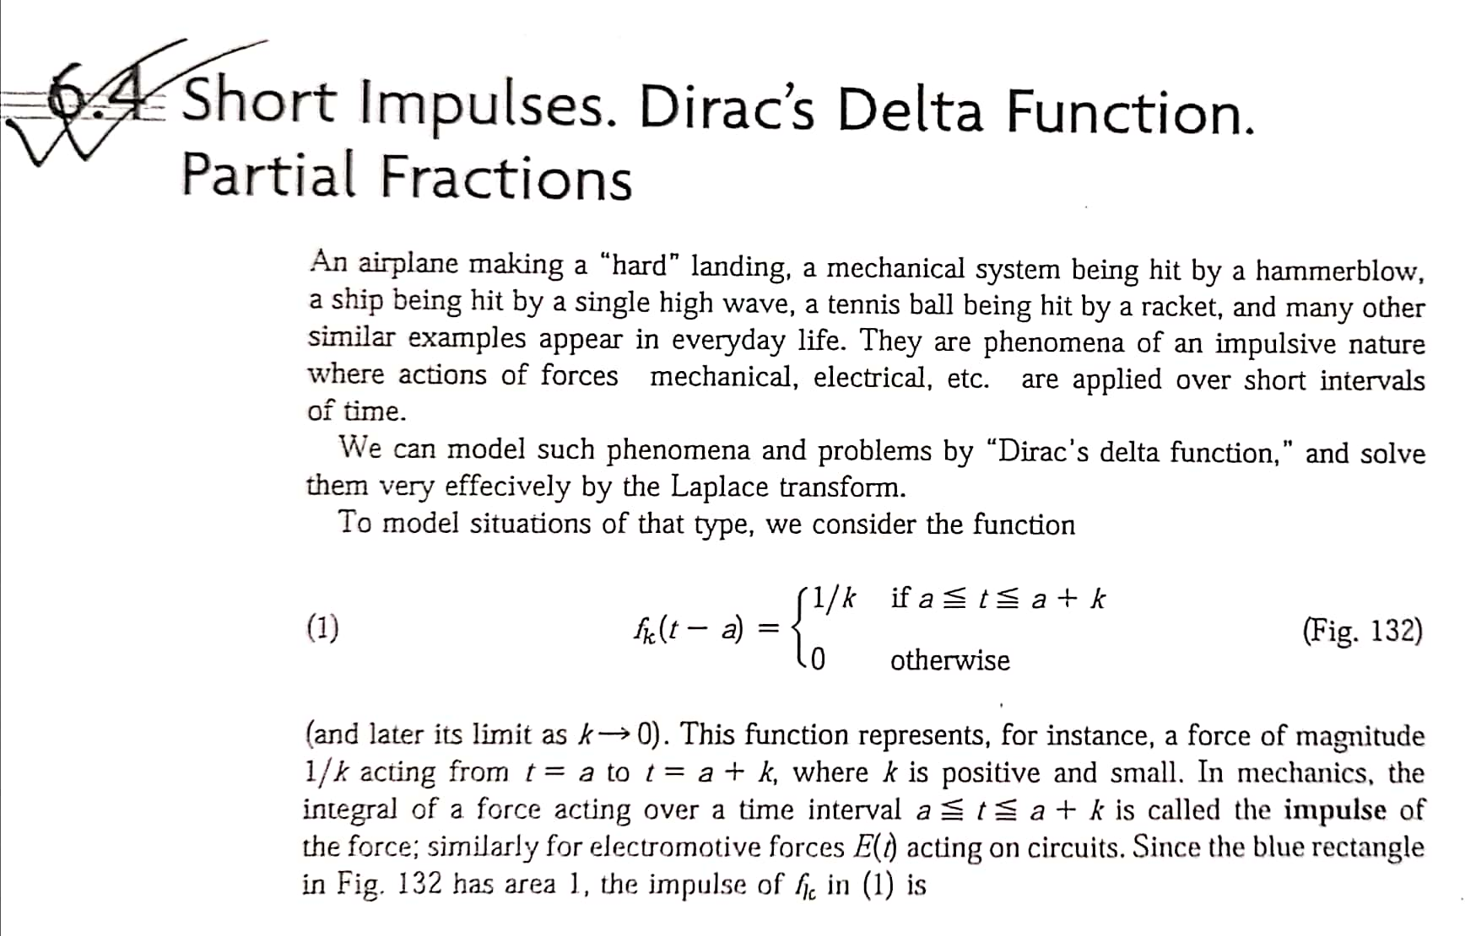

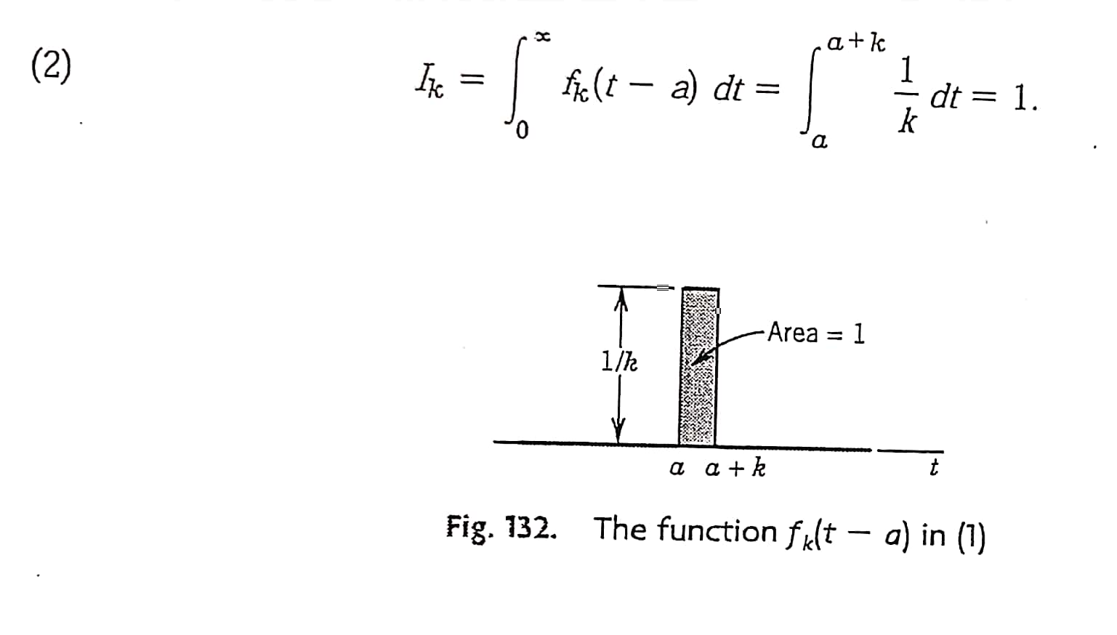

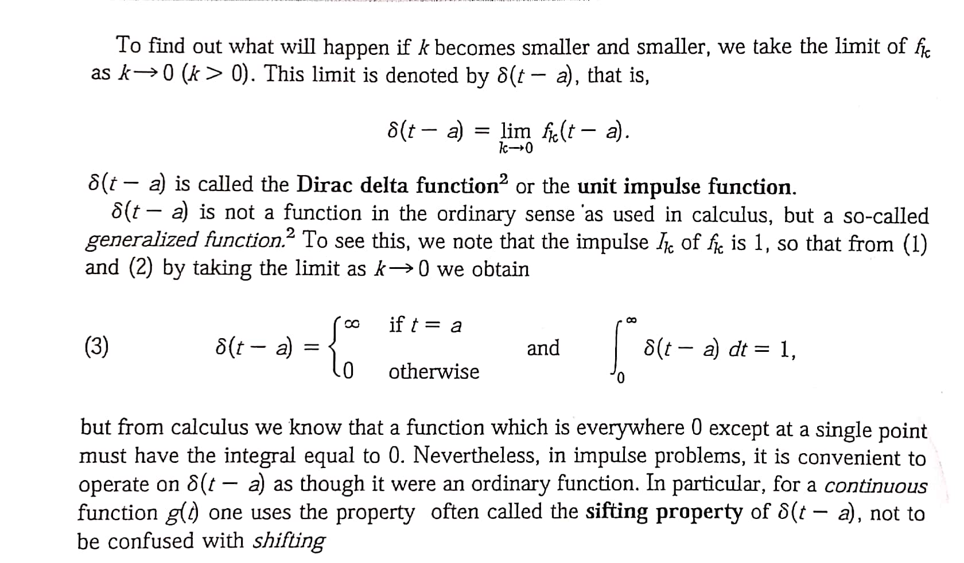

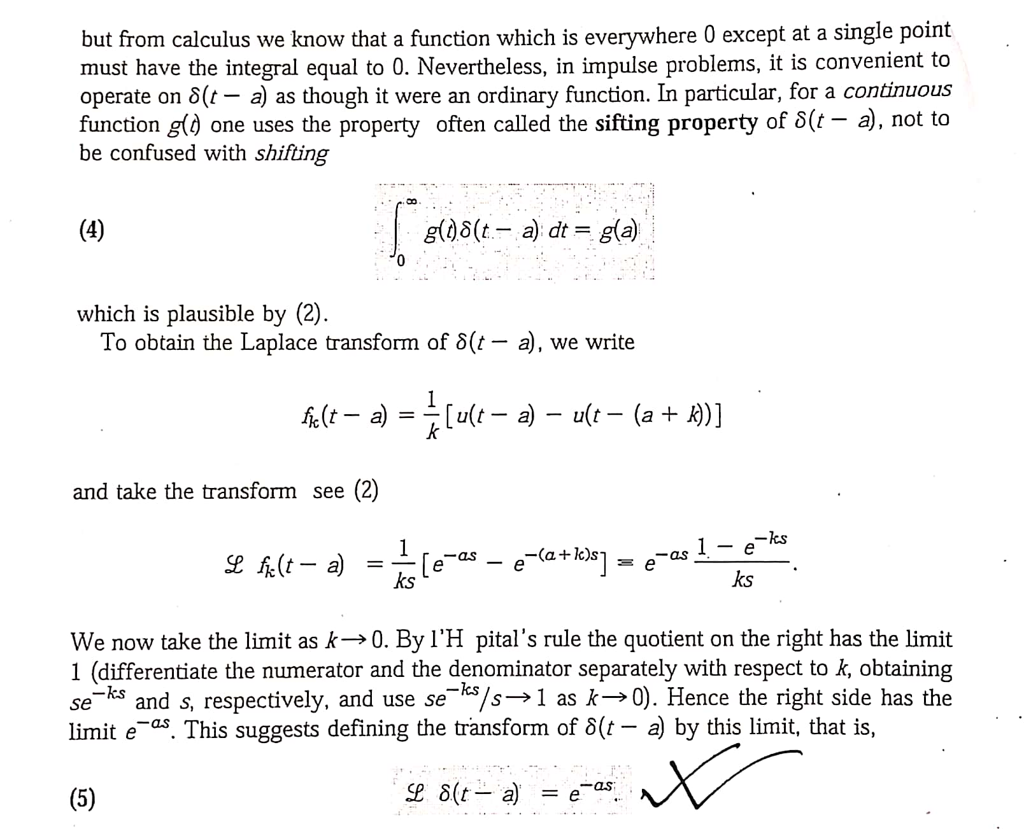

**Problem Set 2**

**Unit step function**

**Sketch the following functions and find their Laplace transforms (21-25):**

21. **Ans:**

22. **Ans:**

23. **Ans:**

24. **Ans**:

25. **Ans:**

**Sketch the following functions. Write $f\left(t\right)$ in terms of unit step function and hence find**

**their Laplace transforms: (26-27)**

26.

**Ans:**

27. ,

**Ans:**

MATLAB answer. $F\left(s\right)= \frac{2}{s^{3}} -e^{-s} \left(\frac{3}{s}+ \frac{1}{s^{2}}+ \frac{2}{s^{3}}\right)→$ 
 By hand calculation. But both expressions are

same.

**Using the following graphs write $f\left(t\right)$ in terms of unit step function and hence find the Laplace transforms of $f\left(t\right):$ (28-29)**

28.

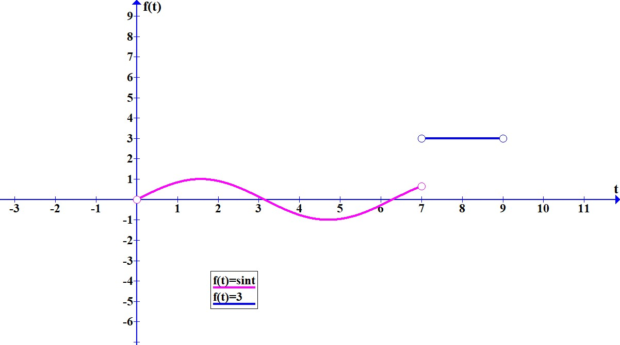

**Ans: $f\left(t\right)=\sin{t u\left(t\right)+\left(3-\sin{t}\right) u\left(t-7\right)-3 u(t-9) .}$**

$F\left(s\right)=e^{-7s} \left(\frac{3}{s} - \frac{\cos{7 + s \sin{7}}}{s^{2}+1}\right) - \frac{3 e^{-9s}}{s} + \frac{1}{s^{2}+1} .$

29.

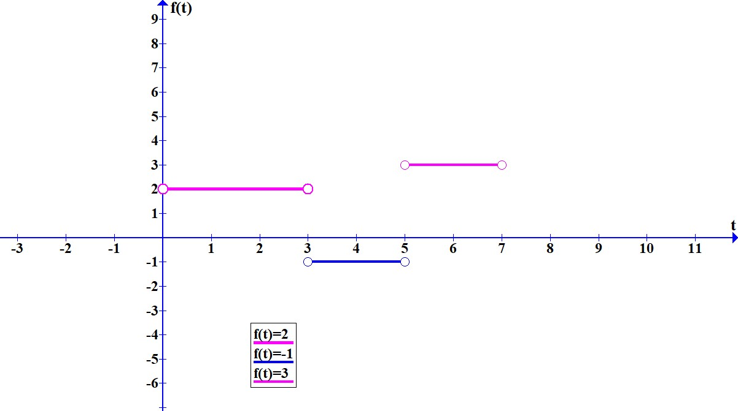

**Ans: $f\left(t\right)=2 u\left(t\right) - 3 u\left(t-3\right) + 4 u\left(t-5\right) -3 u\left(t-7\right).$**

$F\left(s\right)= \frac{4 e^{-5s}}{s} - \frac{3 e^{-3s}}{s} - \frac{3 e^{-7s}}{s} + \frac{2}{s} .$

**Dirac’s delta (Unit impulse) function**

**Sketch the following functions and find their Laplace transforms: (30-32)**

$L\left\{δ\left(t-a\right)\right\}=e^{-as}.$

$L\left\{f\left(t\right) δ\left(t-a\right)\right\}=e^{-as} f\left(a\right)$.

30. $f\left(t\right)=δ\left(t-2\right),$

**Ans:**

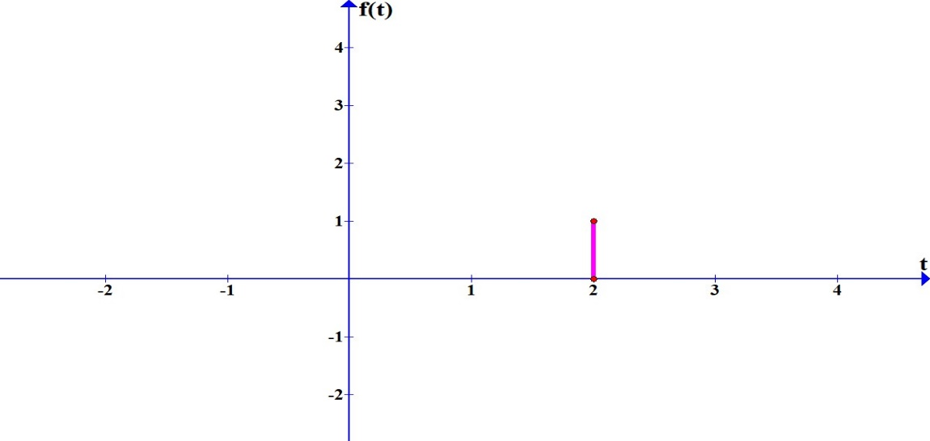

$F\left(s\right)=e^{-2s}.$

31. $f\left(t\right)=2 δ\left(t-3\right),$

**Ans:**

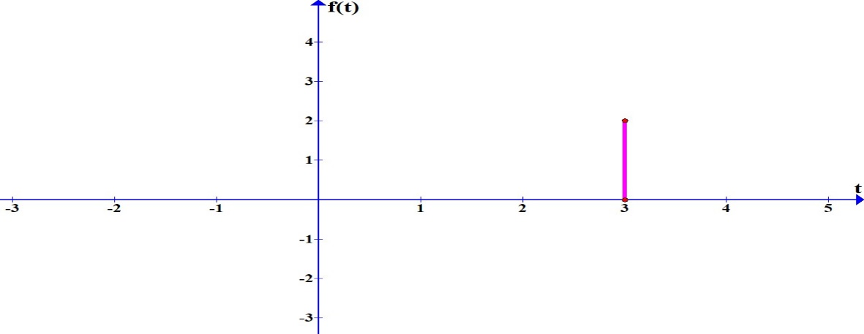

$F\left(s\right)=2 e^{-3s}.$

32. $f\left(t\right)=\sin{t δ\left(t-3\right),}$

**Ans:**

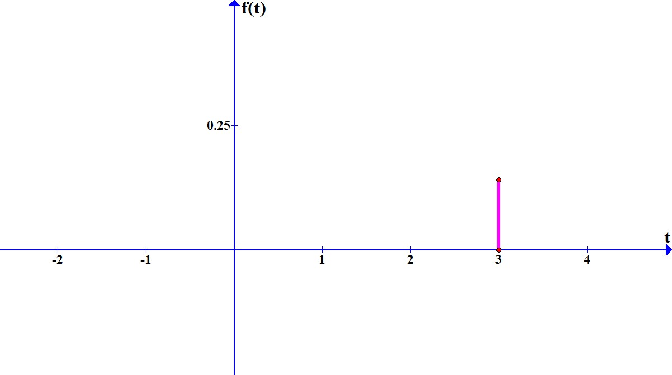

$F\left(s\right)=\sin{3 e^{-3s}.}$